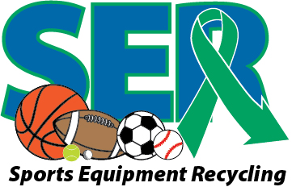
Equipment Wish List

If you have any of the items listed below or other sports equipment you are no longer using, please consider donating to this program. Equipment collected will be given to students with special needs at YOUR school and throughout Pitt County.

The following is a list of items in high demand, but any and all equipment donations are welcome!

Bicycle Equipment Needs:  Bikes – old, new, big, small  Stationary bikes  Bicycle training wheels  Glide/Balance Bikes  Bicycle Helmets  Stationary hand cycles  Recreation Equipment Needs:  Bocce sets – indoor and outdoor  Horseshoe sets – metal or plastic  Disc golf targets/goals  Frisbee golf discs  Cornhole boards  Cornhole bags  Mini golf mats – putting greens  Fishing poles  Adaptive fishing poles  Archery equipment  Ring toss  Rubber bowling balls (heavy)  Small parachutes  Aquatic Equipment Needs:  Goggles/swim masks  Floating or side mounted basketball goals  Floating volleyball nets  Kick boards  Pool toys  Apparel Needs:  Sneakers – gently used, all sizes  Hats – all styles  Team jerseys/shirts – all teams, all sizes  Small duffle bags/book bags | Fitness Needs:  Cones  Pedometers  Stethoscopes  Large therapy/exercise balls  Agility ladders  Medicine balls  Jump ropes  Resistance bands  Heart rate monitors  Hand/wrist weights  Floor markers – poly spots, hands, feet, directional arrows, etc…  Tape measure – 100-200 ft  Specific Sport Equipment Needs:  Softball/Baseball gloves  Lacrosse sticks  Frisbees  Portable basketball goals – small  Hockey sticks  Baseball/Softball bats  Collapsible goals – volleyball, soccer,  basketball, hockey, etc…  Balls – soccer, basketball, golf, beach,  baseballs, kickballs, footballs, etc…  Technology Needs:  Wii remote controls  Wii Games – sports or fitness related  Projectors  Stopwatches  And MUCH MORE!

